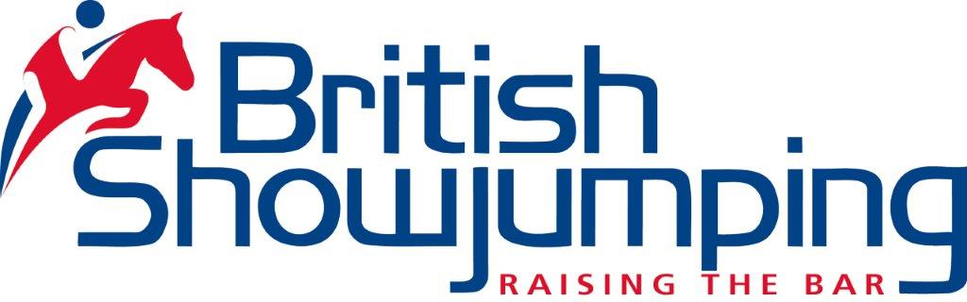 

**Musculoskeletal Development and its Association with Function and Performance  
With Mia Palles Clark and Jane Hart**

10 April 2018 at Writtle University College, Cow Watering Campus, Cow Watering Lane, Writtle, Chelmsford, CM1 3SD.

Draft timetable:

|  |  |
| --- | --- |
| 9.30-10am | Welcome Tea and Coffee |
| 10am | Theory:– Overview of the Scale of Training  Identify key muscle groups in relation to the correct way of going  ‘Ages and Stages’ of muscle development for flat and jump training.  Pre-habilitation, strengthening and maintenance of competition horses |
| 11-11.15am | Break |
| 11.15am | Influence of the rider  Consequences of asymmetry (for horse and rider). Discussions using video clips. |
| 12.00 | Practical Session –  ‘Live labelling’ and chalking of anatomical land marks and key muscle groups in relation to function. |
| 1.30-2.15pm | Lunch break |
| 2.15pm | Practical – watching horses move and jump in relation to the morning’s discussions, relating to the ‘Ages and Stages of Training’.  Focus on strengthening and injury prevention. |
| 4.00pm | Round up and finish |

£40/British Showjumping Members, £45/non-members

You are welcome to bring your own lunch or a buffet lunch can be provided at an additional £9/head which must be ordered at the time of booking.

Please note that fees will be added to your online membership account.  Non-members will be asked to join as web members which is free of charge (<https://members.britishshowjumping.co.uk/security/assist>).  The British Showjumping cancellation policy will apply.

To book, please email Ruth McKiernan (East and East Midlands Development Officer) on [ruth.mckiernan@britishshowjumping.co.uk](mailto:ruth.mckiernan@britishshowjumping.co.uk) stating your membership or web membership number.  Please note that this session does not count as an official CPD workshop for British Showjumping level 3 coaches.